AS Film Studies
Core Study Area: Film form: Cinematography
Provide illustrated and identified examples for each of the following film form features:
Shot Length/ Lighting | Film still | Film name (Director, Year)  and definition and effect
Extra Long Shot (ELS / XLS) |  | The Shining  Stanley Kubrick  1980  Human is equal to or less than 1/3rd the height of the frame.  Identifies the location and/or establishes the kind of place/genre of film
Long shot (LS) | 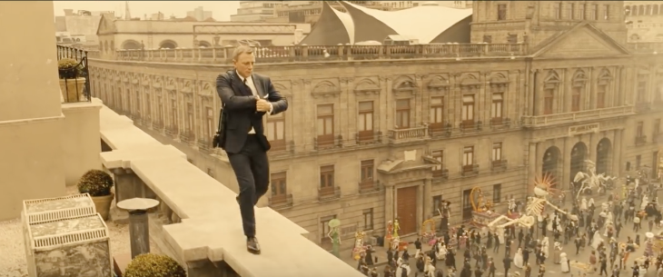 | Spectre  Sam Mendes  2015  Shows the entire object or human figure and is usually intended to place it in some relation to its surroundings.
Mid Shot (MS) | 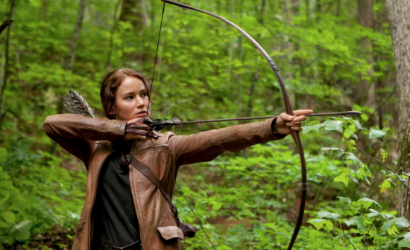 | The Hunger Games  Gary Ross  2012  Shows equally between subjects and background from the waist up.
Close up (CU) | 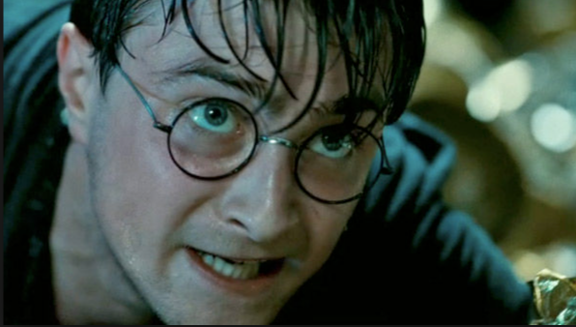 | Harry Potter and the Deathly Hallows part 2  David Yates  2011  Used to show facial expressions/emotions.
Extreme Close Up (ECU / XCU) | 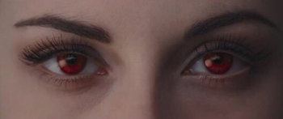 | The Twilight Saga: Breaking Dawn part 1  Bill Condon  2011  Shows detailed facial features e.g. eyeballs
High Key Lighting | 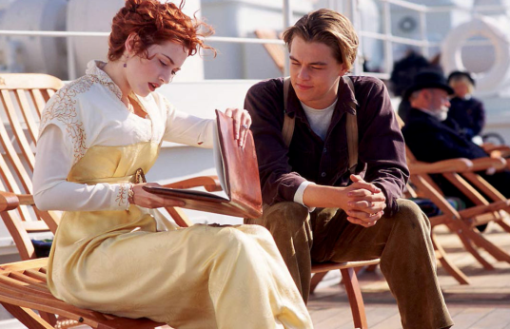 | Titanic  James Cameron  1997  When the scene is brightly lit. Used to show purity and happiness.
Low Key/High Contrast Lighting | 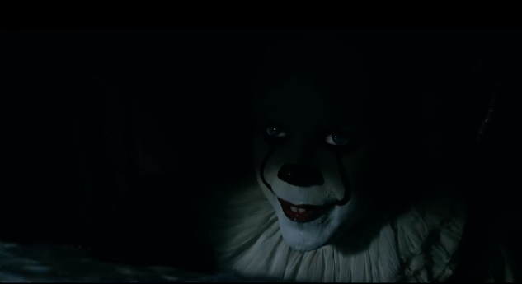 | IT  Andrés Muschietti  2017  When the scene is mainly dark. Used to create suspense and drama.

